**LINEAR REGRESSION**

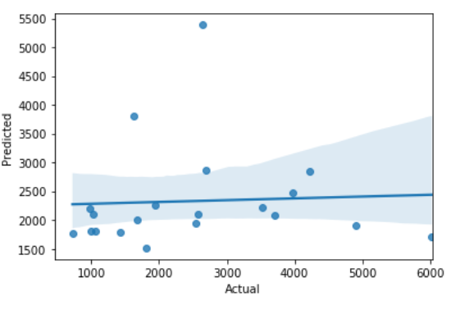

**Mean Absolute Error:** 1270.0766577119025

**Mean Squared Error:** 2711559.855803576

**Root of Mean Squared Error:** 1646.6814676201273

**DECISION TREE**

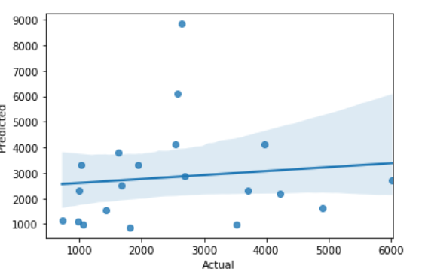

**Mean Absolute Error:** 1693.4

**Mean Squared Error:** 5142351.5

**Root of Mean Squared Error:** 2267.675351543955